**How to Clean and Maintain Your Persian Rug: A Guide**

For many people, owning a [Persian rug](https://en.wikipedia.org/wiki/Persian_carpet) symbolizes luxury and wealth. These beautiful [handmade rugs](https://www.rugmaster.com.au/) come in various designs and colors and can add a touch of elegance to any room. However, with this stunning beauty comes the responsibility of keeping your rug clean and well-maintained. This guide will provide the necessary information on how to properly clean your Persian rug so that it maintains its beauty and lasts for years.

What is a Persian Rug?

Before diving into cleaning and maintaining a [Persian rug](https://en.wikipedia.org/wiki/Carpet), let us first understand what it is. A Persian rug, also known as an Iranian rug, is a handmade rug that originates in [Iran](https://en.wikipedia.org/wiki/Iran). These rugs come in different designs, styles, and sizes, with each rug having its unique patterns and color schemes.

Persian rugs are traditionally made of [wool](https://www.rugmaster.com.au/product-category/rugs-kilims/village-tribal/wool-rugs-handmade/), silk, or cotton, with the majority being wool. The wool comes from sheep and is a durable and resilient material. Silk is used for luxury and adds a shine to the rug. Cotton is used to provide a firm foundation for the rug. A handmade rug can take months or even years to complete, and its cost reflects the labor involved in making it.

Why [Clean](https://www.rugmaster.com.au/rug-wash-and-repair/) and Maintain Your Persian Rug?

A Persian rug is a long-term investment that can last up to 100 years if maintained properly. However, it can quickly deteriorate if not cared for, losing its value and beauty. Dirt, dust, and debris can accumulate in the fibers of the rug, leading to the rug looking dull and faded. Additionally, spills can leave behind stains that can be challenging to remove, reducing the rug's value.

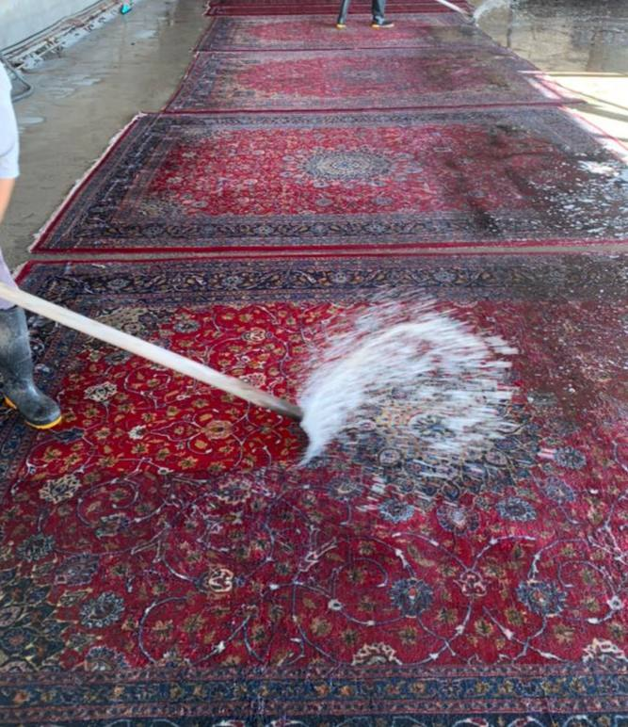

Cleaning and maintaining your Persian rug correctly will keep it looking beautiful and prolong its lifespan, making it a worthwhile investment for generations to come.

Cleaning Your Persian Rug

Cleaning a Persian rug requires caution to avoid damaging the rug fibers. Here is a step-by-step guide on how to clean your rug properly:

Step 1: Vacuum Your Persian Rug

The first step to cleaning your Persian rug is to vacuum it. Use a low-power vacuum cleaner with a brush or an attachment for cleaning rugs. Vacuum the rug toward the pile, careful not to vacuum the fringe. Make sure you vacuum the rug's backside to remove any loose dirt and debris.

Step 2: Spot Clean Stains

If there are any stains on your Persian rug, it is essential to clean them immediately to prevent them from settling into the fibers. Blot the stain with a clean, white cloth or paper towel to remove any excess liquid. Mix a solution of water and mild soap and gently dab the stain using a clean cloth. Avoid rubbing the stain, as it can spread and damage the fibers.

Step 3: [Wash](https://www.rugmaster.com.au/rug-wash-and-repair/) Your Rug

If your Persian rug needs a deep clean, a wash is required. While you can wash your rug at home, we recommend letting a professional do it. A professional cleaning service will ensure that your rug is washed with the appropriate cleaning products and techniques, ensuring it remains in good condition.

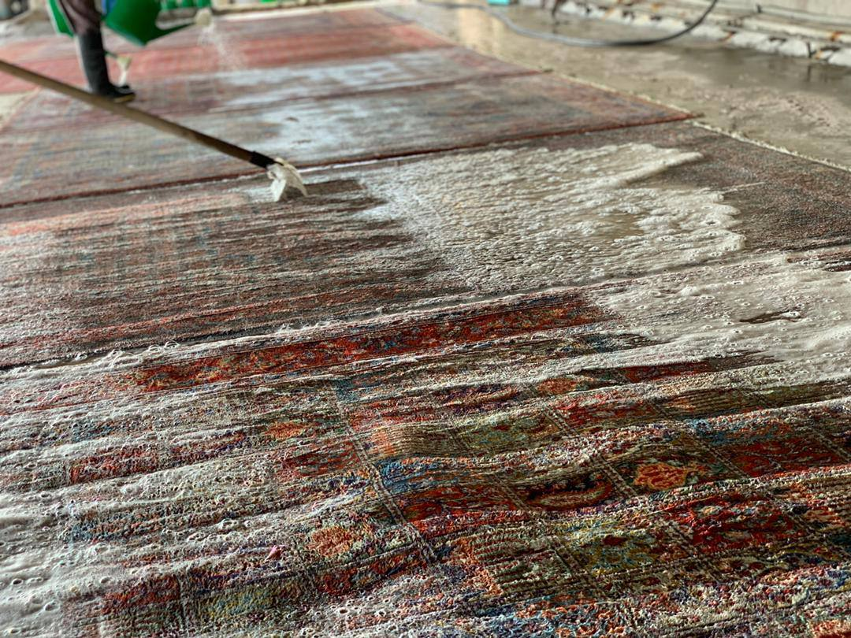

Maintenance Tips for Your Persian Rug

Here are some tips and recommendations to maintain your Persian rug's beauty and prolong its lifespan:

Rotate your rug every six months to prevent uneven wear, particularly in high-traffic areas.  
Avoid placing your rug in direct sunlight, which can fade the colors and weaken the fibers.  
Protect your rug from spills by using a rug pad under it.  
Avoid placing heavy furniture on your rug, as it can leave permanent dents.  
Keep your rug dry to prevent mold growth, and avoid cleaning it with excess moisture.  
Use a specialized rug cleaner and avoid harsh chemicals that can damage the fibers.  
Where to Buy Persian Rugs

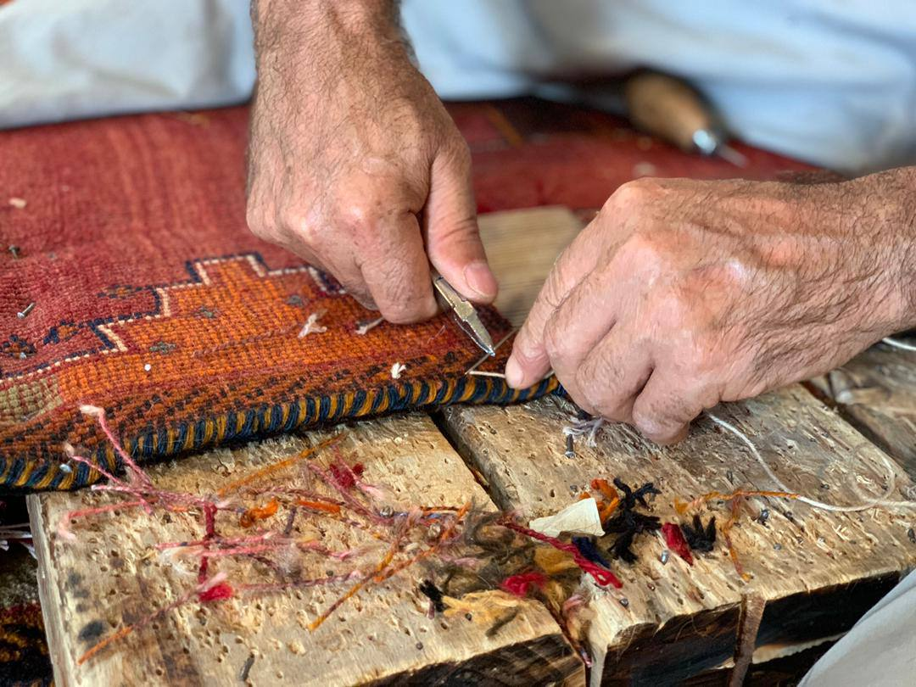

If you want an authentic handmade Persian rug, you might consider buying one from a reputable rug shop. There are various Persian rugs, such as [traditional](https://www.rugmaster.com.au/product-category/rugs-kilims/vintage-rugs/) Persian rugs, [vintage Persian rugs](https://www.rugmaster.com.au/product-category/rugs-kilims/vintage-rugs/), and Persian-style rugs. These rugs have unique designs that can complement your home's [interior design](https://en.wikipedia.org/wiki/Interior_design).

When it comes to purchasing Persian rugs, shopping online can be a convenient and hassle-free option. However, it's essential to ensure that you're buying from a trustworthy source to get an authentic product.

At our [online store](http://rugmaster.com.au/shop/), we take great pride in offering a vast collection of genuine Iranian handwoven carpets sourced from various regions of Iran. Our rugs are crafted by skilled artisans using traditional techniques, resulting in exceptional quality and striking designs that are sure to impress.

We're committed to providing our customers with an excellent shopping experience, so we offer exceptional customer service to ensure that you're satisfied with your purchase. When you shop with us, you can rest assured that you're getting a top-quality Persian rug that will add warmth and elegance to your home.

If you're located in Australia, some of the best places to buy Persian rugs online are Persian Rugs Melbourne, Persian Rugs Sydney, Persian Rugs Perth, Persian Rugs Brisbane, Persian Rugs Hobart, Persian rugs Canberra, Persian Rugs Gold Coast and Persian Rugs Adelaide. However, we encourage you to shop with us to experience the exceptional quality and customer service that we're known for.

[Buy a rug](http://rugmaster.com.au/shop/)

[Need to clean the Rug](https://www.rugmaster.com.au/rug-wash-and-repair/)

Conclusion

Owning a Persian rug comes with responsibility. Proper cleaning and maintenance are essential if you want to enjoy the rug's beauty and longevity. Following the tips outlined in this guide, you can keep your rug in excellent condition for years. Whether you have a traditional Persian rug or a vintage one, ensuring it remains clean and well-maintained will make it a worthwhile investment.